Step 1 – Install and configure the fre:ac audio converter.
fre:ac is free and can be downloaded from www.freac.org. The following encoder settings produce a good balance between sound quality and file size.
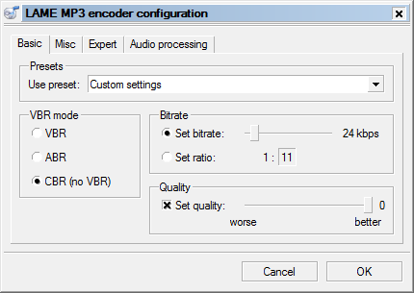
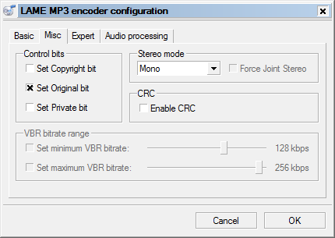
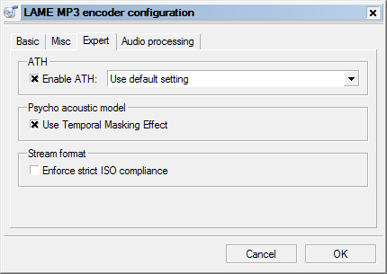
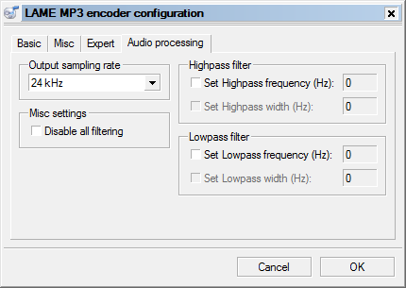

Step 2 – Rip the sermon using fre:ac.
- Insert the sermon CD and then click the add audio button.
- Click the sermon recording in the list to select it.
- Enter the preacher’s name.
- Enter the sermon text and title.
- Enter the service, which is typically “Morning Worship” or “Evening Worship”.
- Enter the track, which is typically the number of the week for that Sunday.
- Enter the year.
- Enter the genre, which is typically “sermon”.
- Enter the output directory where you want the MP3 file to be created.
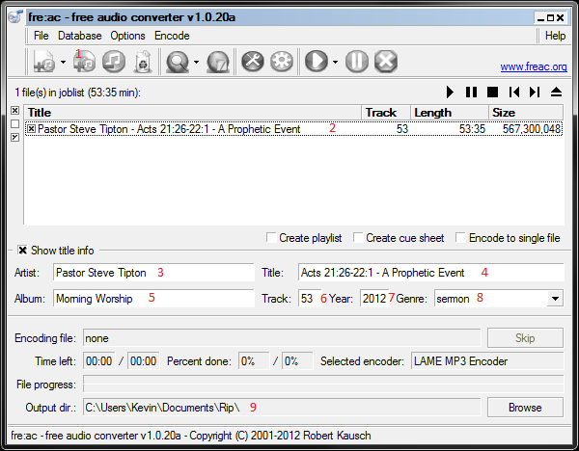

Step 3 – Title and tag the MP3 file.
- Rename the file using the pattern “yyyymmdd-ss-nnnnnn.mp3”, where “yyyy” is the 4 digit year, “mm” is the 2 digit month, “dd” is the 2 digit day of the month, “ss” is the service (typically “mw” or “ew”), and “nnnnnn” is the last name of the preacher. E.g., “20121230-mw-tipton.mp3”. This title pattern is important for displaying the sermons in the proper order.
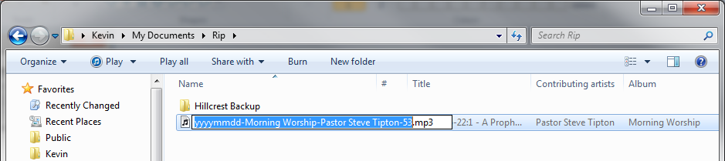
- Add the website domain to the MP3 ID comments tag.
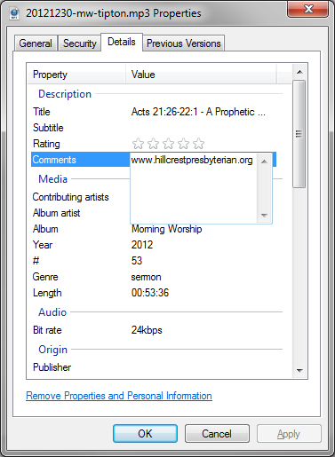

Step 4 – Trim the recording using mp3DirectCut.
mp3DirectCut is free and can be downloaded from http://mpesch3.de1.cc/. Open the audio file, drag to select any excess recorded material prior to the start of the sermon, then select cut. Then do the same for any excess after the prayer of application and submission.
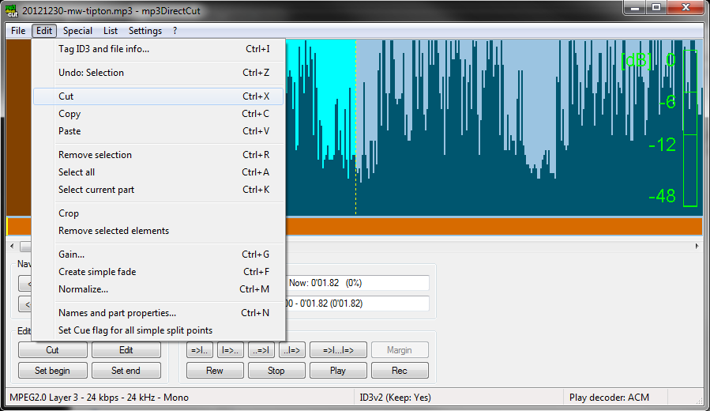
Then save the trimmed file’s complete audio.
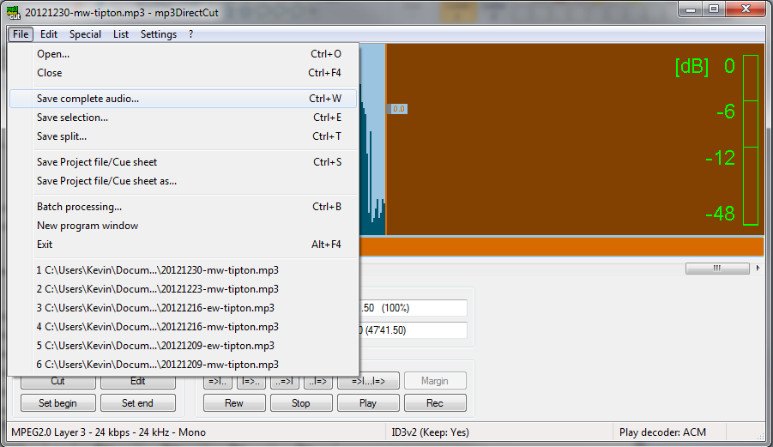
Step 5 – Upload the sermon file to the website.
- Log into the www.hillcrestpresbyterian.org WordPress website.
- Navigate to add new media.
- Drag the sermon file over the upload new media drop file area.
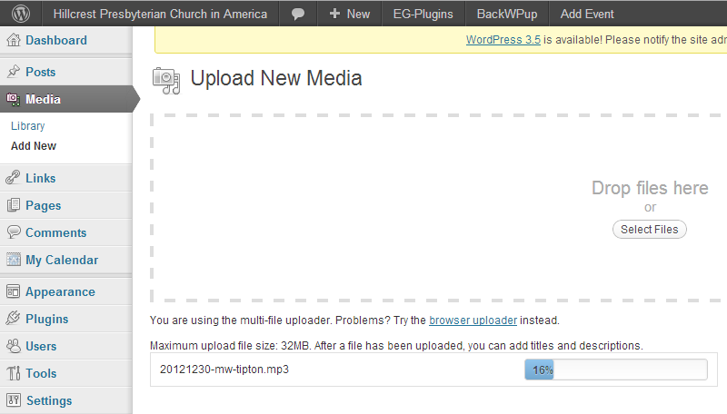
- When the upload finishes, enter the sermon title, the preacher’s name in the caption field, and the numeric date formatted as “mm/dd/yyyy”. Then click the save all changes button.
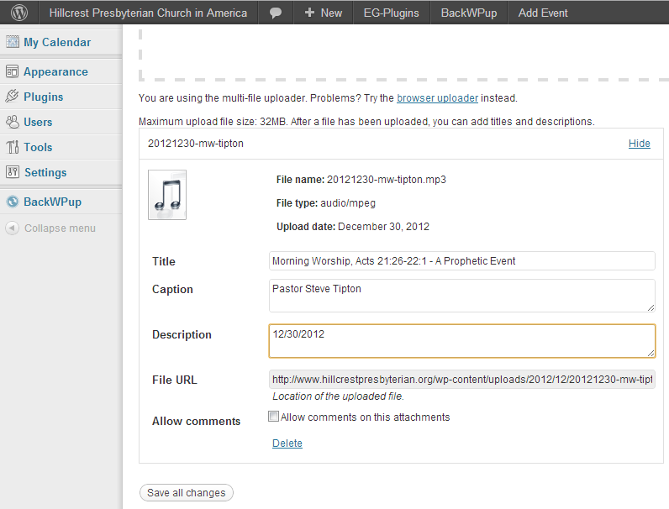
- Attach the new file to the sermons page from the media library page.
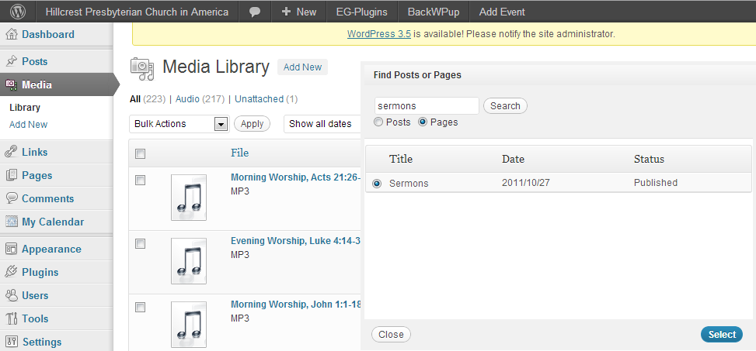
- Verify that the uploaded sermon is displaying on the sermons page.

Step 6 – Upload the sermon file to Box.
The sermon files are copied to Box storage as a backup and for older sermons that cannot fit into the website’s storage.
- Log into www.box.com.
- Navigate to web > Hillcrest PCA Sermons > 2013 (or whatever year the sermon was preached).
- Drag the sermon file over the files list and drop it to upload.
- Add the sermon information to the file’s general file info description.
